Homework – 5

1. Consider the grammar $G=(V,Σ,R,S)$, where

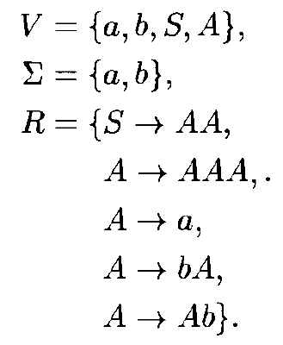

a). Give a string of $L(G)$ that can be produced by applying the rules at most 4 times

b). Same string can be derived in different ways, e.g., $S⇒AA⇒aA⇒aa$, $S⇒AA⇒Aa⇒aa$. Give at least 2 distinct derivations for the string $babbab$

c). For any $m,n,p>0$, describe a derivation in $G$ of the string $b^{m}ab^{n}ab^{p}$

1. Consider the grammar $G=(V,Σ,R,S)$, where

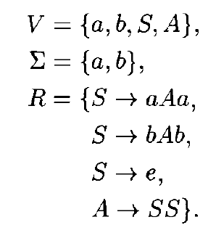

Give a derivation of the string $baabbb$ in $G$.

1. Show that the following languages are context-free by exhibiting contextfree grammars generating each.

a). $\{a^{m}b^{n}:m≥n≥0\}$

b). $\{a^{m}b^{n}c^{2m+n}:m,n≥0\}$